INSTITUTIONAL PROGRAM REVIEW 2009-10
Program Efficacy Phase, Spring, 2010

Purpose of Institutional Program Review

Welcome to the Program Efficacy phase of the San Bernardino Valley College Program Review process. Program Review is a systematic process for evaluating programs and services annually. The major goal of the Program Review Committee is to evaluate the effectiveness of programs, and to make informed decisions about budget and other campus priorities.

The Institutional Program Review Committee is authorized by the Academic Senate to develop and monitor the college Program Review process, receive unit plans, utilize assessments as needed to evaluate programs, recommend program status to the college president, identify the need for faculty and instructional equipment, and interface with other college committees to ensure institutional priorities are met.

The purpose of Program Review is to:
❑ Provide a full examination of how effectively programs and services are meeting departmental, divisional, and institutional goals
❑ Aid in short-range planning and decision-making
❑ Improve performance, services, and programs
❑ Contribute to long-range planning
❑ Contribute information and recommendations to other college processes, as appropriate
❑ Serve as the campus’ conduit for decision-making by forwarding information to or requesting information from appropriate committees

Our Program Review process is two-fold. It includes an annual campus-wide needs assessment in the fall, and an in-depth review of each program every three years that we call the Program Efficacy phase. Instructional programs are evaluated the year after content review, and every three years thereafter, and other programs are placed on a three-year cycle by the appropriate Vice President.

An efficacy team of two disinterested committee members will meeting with you to carefully review and discuss your document. You will receive detailed feedback regarding the degree to which your program is perceived to meet institutional goals. The rubric that the team will use to evaluate your program is included with this e-mail

When you are writing your program evaluation, you may contact efficacy team assigned to review your department or your division representatives for feedback and input. The list of readers is being sent to you with these forms as a separate attachment.

Forms are due back to the Committee Chairs, Efficacy Team and Division Dean by April 1, 2010.
It is the writer’s responsibility to be sure the Committee receives the forms on time.

In response to campus wide feedback that program review be a more interactive process, the committee will pilot a program efficacy that includes a review team who will interviews and/or tour a program area during the efficacy process. Another campus concern focused on the duplication of information required for campus reports. The pilot will incorporate the Educational Master Plan One-Page Summary (EMP Summary) and strive to reduce duplication of information while maintaining a high quality efficacy process. More details on the pilot can be found in the attached file.

Program Efficacy, Spring 2010

Complete and attach this cover sheet as the first page of your report.

Program Being Evaluated
Paralegal Studies

Name of Department:
Paralegal Studies

Name of Division
Library, Learning Resources and Communication Media

Name of Person Preparing this Report Extension
Patti Wall X8577

Name of Department Members Consulted
Click here to enter text.

Name of Efficacy Team
Michael Mayne Ext 8536; Marianne Klingstrand Ext 8239

Program Review Committee Representatives
Celia Huston

Work Flow | Due Date | Date Submitted
Date of initial meeting with department | March 22,2010 | Click here to enter text.
Final draft sent to the dean | Click here to enter text. | March 30, 2010
Report submitted to Program Review Team |  | April 1, 2010
Meeting with Review Team | Click here to enter text. | Click here to enter text.

Staffing
List the number of full and part-time employees in your area.
Classification | Number Full-Time | Number Part-time, Contract | Number adjunct, short-term, hourly
Managers | 1 | 0 | 0
Faculty | 0 | 0 | 5
Classified Staff | 0 | 0 | 0
Total | 1 | 0 | 5

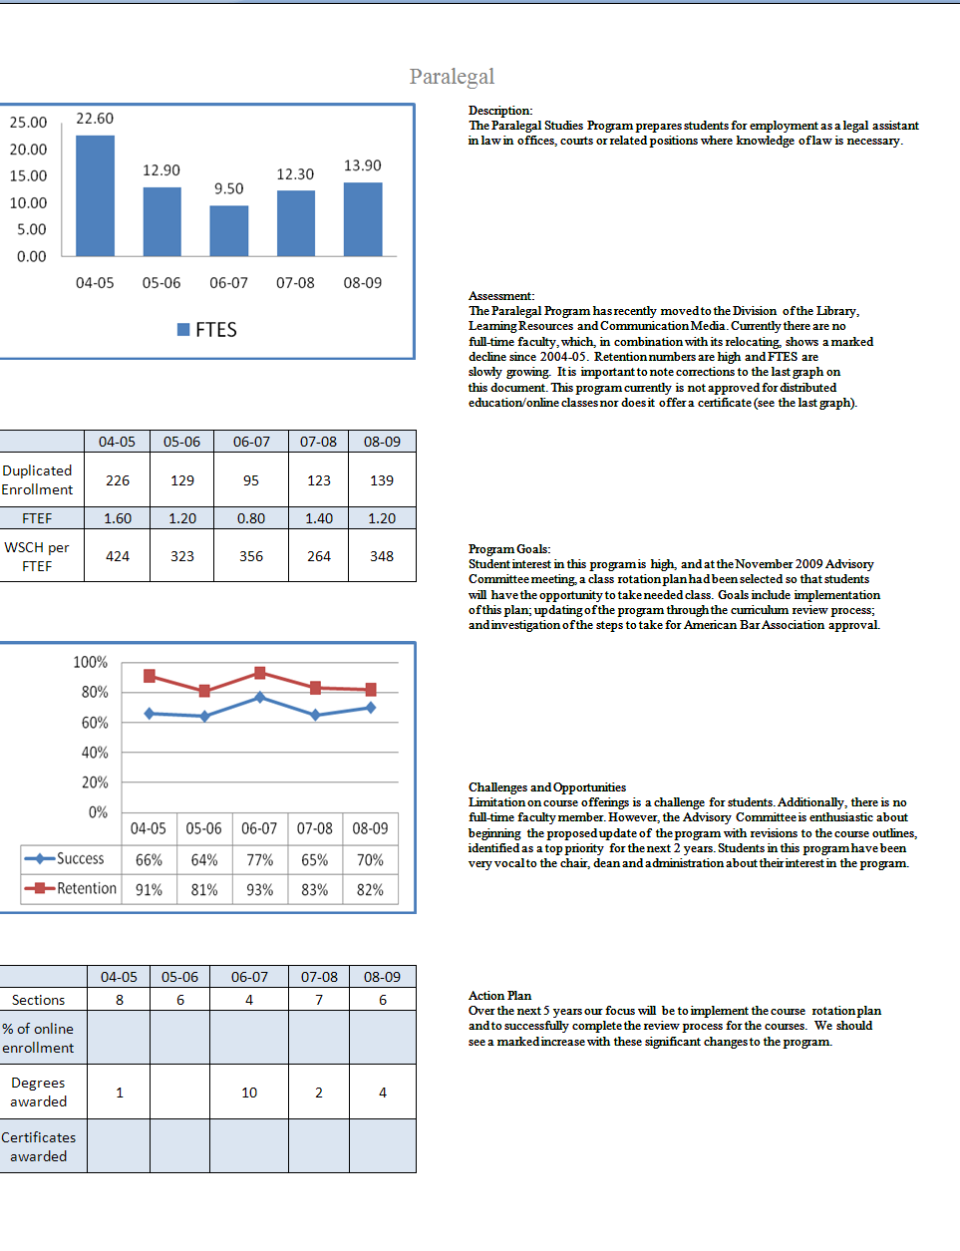
Part I. Questions Related to Strategic Initiative: Access

Use the demographic data provided to describe how well you are providing access to your program by answering the questions below.
Click here to enter text.
Does the program population reflect the college’s population? Is this an issue of concern? If not, why not? If so, what steps are you taking to address the issue?

Based on the demographic information received reflecting the Fall 2004-Fall 2007 semester, the Paralegal Studies Program exhibited consistently higher retention rates than the campus average. Campus averages ranged from 76-80%. The Paralegal Program displayed 81-93%.

The program shows a small variance between Asian and White populations and is not an area of concern currently. It is noted that there is a slightly higher rate of Black students in the program which is 9% higher than the rest of the campus. Since we were provided only one year worth of data, this percentage might average out differently over a longer period. We will watch the data over the next 3-years to see if our marketing strategies (attending career events, developing flyers and program brochures, etc.) will make an impact. If not, we will develop an additional plan to target other ethnic groups.

We are seeing a high percentage of females in the program. According to the U.S. Office of Personnel Management http://www.lawcrossing.com/article/1301/In-a-Pink-Collar-Profession-Male-Paralegals-like-Wal-Mart-s-Robert-Stephens-Find-Profit this trend is common for the Paralegal profession. They state, “…in 1998 that nearly 80 percent of paralegal specialists were women. According to a study by USA Today, men held 15.3 percent of the country’s legal assistant jobs in 2000 and close to 18 percent in 2002. However, in a 2002 survey conducted by the Orange County Paralegal Association, 94 percent of the respondents were women; and a 2004 NALA survey showed that 96 percent of respondents where women. In 2005, the Bureau of Labor Statistics revealed that 13.7 percent of all paralegals were men, which represents an increase of almost 2 percent from 2004 statistics.”

An issue of concern relates to class offerings which shows a downward trend and is based on budget reductions. Taking this into consideration, the Dean has implemented a new course rotation schedule that will allow students to complete the program in 18 months.

Pattern of Service
How does the pattern of service and/or instruction provided by your department serve the needs of the community? Include as appropriate hours of operation/pattern of scheduling, alternate delivery methods, weekend instruction/service.

The Paralegal Studies Advisory Committee met in Fall 2009 (the first semester in its new division) and an important item on the agenda was the rotation schedule that Dean Mestas created. The rotation schedule clearly provides the Paralegal Studies student the opportunity to take the paralegal courses within an 18-month offering and to graduate at the end of that time with a degree. Paralegal classes are scheduled in the evening to accommodate not only the student, but also the attorneys (adjunct faculty) who teach in the program and who work a traditional schedule. At this time there are no plans to provide alternate delivery or weekend instruction since our priority is to update the course outlines so that they are current and that we have fully implemented the course rotation pattern. Course offerings currently are based on the student needs as polled in their class. Beginning Fall 2011 we will have fully implemented the course rotation plan. The curriculum is being updated and once approved we’ll begin the process of determining which class would be appropriate for Distributed Education.

Part II: Questions Related to Strategic Initiative: Student Success
Provide a brief analysis of the data and narrative from the program’s EMP Summary and discuss what it reveals about your program.
From the EMP Summary data, 2006-2007 exhibited a low point in the program with 9.50 FTES. This trend has been on the rise since that time and 2008-2009 data exhibits 13.90 FTES. “Retention” of students in the Paralegal Studies Program looks high according to the data, with ranges in 2004-2005 of 91% to currently 82%. Additionally, “success” ratings vary somewhat from 65% as a low to a high of 77%. The program seems relatively good for not having a fulltime faculty member. There is student interest in the program and the division continues to receive inquiries which average about 1-to-2 calls a week. The counselor for the program, Patty Jones, has also indicated at a meeting (Wednesday, February 24, 2010) that she has many people asking her about the program. This shows that potential and current students are interested in the program.
Supplemental Data
Provide any additional information such as job market indicators, standards in the field or licensure rates that would help the committee to better understand how your program contributes to the success of your students.
Presented at the November 6, 2009 Advisory Committee Meeting was the latest information from the Employment Development Department website www.labormarketinfo.edd.ca.gov for Paralegals and Legal Assistant--Occupation Profile. The estimated employment given for the state of California for years 2006-2016, was 24,700 with 31,200 projected openings. The website states that the annual average openings are 970 for our area and the 2009 Wages in the Inland Empire Area for this occupation being $49,965 as an annual median income and a median hourly wage of $24.02.

Student Learning Outcomes
Program has SLO’s on file with the Office of Instruction.
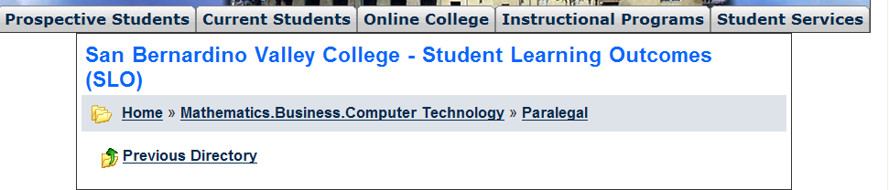
The list above shows the courses that have SLOs on file with the Office of Instruction.

If you have courses for which SLOs have not been developed, explain why. What are your plans to remedy this?
The Paralegal Studies program SLOs have been developed and were in the course folders that were sent over to our division. The division has been in-touch with the Office of Instruction and has scanned the SLOs and emailed them so that they may be posted at the campus website. Web address for SLOs:

http://depts.valleycollege.edu/SLO/index.php?CurrentDir=%2FLibary.Learning_Resources.Communications+Media%2FPARALGL%2F

Attach your three-year plan for assessing SLOs.

What progress has the program made in its three-year plan? Have you implemented any program changes based on assessment results?

In Spring 2009 assessment was completed for two courses. One, PARLGL 100, Law Office Management for the Paralegal exhibited approximately 85% of the class were able to meet SLOs. The remaining 15% were familiar with the criteria but were lacking in proficiency in some area. The instructor viewed these results as successful. PARLGL 120, Wills, Probate and Estate Planning, exhibited approximately 90% of the class meeting SLO goals. The remaining 10% were familiar with the requirements but were unable to validate that knowledge on an exam or assignment. This class, also, was seen as successful.

A three-year plan for assessment in a written format has not been located. The former secretary for the program in the Business Division was contacted and researched to see if she could find one. She also sent us correspondence from the former dean with the overall campus plan, but no plan specific to the program was implemented. An assessment plan will be developed this semester (Spring 2010) and implemented in Summer 2010.

Part III. Questions Related to Strategic Initiative: Institutional Effectiveness
Mission and Purpose
What is the purpose of the program?

Our Mission: San Bernardino Valley College provides quality education and services that support a diverse community of learners.
The Paralegal Studies Program prepares students for employment as legal assistants providing organizational, management and writing skills and in-depth knowledge of legal procedures that impact law offices, courts or related positions where knowledge of the law is necessary.

How does this purpose relate to the college mission?

The college mission is to “provide quality education and services that support a diverse community of learners.” The purpose of the paralegal studies program supports the college mission by providing a quality education that supports a diverse community of learners. Additionally, it supports student goals by providing skills and a degree that will enable them to enter a well-paying career field in 18 months.

Productivity
Provide additional analysis and explanation of the productivity data and narrative in the EMP Summary, if needed.
FTES for 2008-2009 were 13.90 and have been on the increase since a low in 2006-2007 of 9.50. As comparison based on the EMP Report, 2004-2005 exhibited 22.60 FTES. Considering the program utilizes only part-time faculty (and does not currently have any full-time faculty), it could be considered at an acceptable productivity level.

Relevance and Currency, Articulation of Curriculum
If applicable to your area, describe your curriculum by answering the following questions.
Paralegal
 | Course | Status | Last Content Review | Next Review Date
 | PARLGL098 Paralegal Work Experience | Launched | 03/11/2004 | 03/11/2010

The Content Review Summary from Curricunet indicates the programs current curriculum status. If curriculum is out of date, explain the circumstances surrounding the error and plans to remedy the discrepancy.
Although there was some work done to the program when it was in another division, the changes were not submitted to the Curriculum Committee nor approved by the District Board. This is the second semester that the program has been in its new division and the department head is working with adjunct faculty and the Dean to update the program.
One way the program is undergoing significant and positive changes is that in the first semester it came to our division an advisory committee was formed and met within 3-months of it moving to our division. The committee enthusiastically gave recommendations on changes to the program which are being implemented.
Another way that our division is addressing the dire need for content review is by the course revisions that are currently entering the Curriculum Review process (in addition to what has been copied and pasted above, PARLGL 100, 110, 111, 120, and 205 have been submitted to the Curriculum Committee) and updates to the program should be completed by the end of the current Spring 2010 semester. A new paralegal work experience course, PARLGL 098 which is specifically for the paralegal, has just been developed and approved by the Curriculum Committee and will be part of the updated degree. Any curriculum approved during this time has a start date of fall 2011 (which is the standard date for any course/programs at the curriculum review level currently). A course rotation has been developed so that students may complete the degree in a timely, 18-month offering.

Articulation
List Courses above 100 where articulation is not occurring | With CSU | With UC
Click here to enter text. | Click here to enter text. | Click here to enter text.
Click here to enter text. | Click here to enter text. | Click here to enter text.
Click here to enter text. | Click here to enter text. | Click here to enter text.
Click here to enter text. | Click here to enter text. | Click here to enter text.

Describe your plan to articulate these classes.
All paralegal courses articulate with the exception of the work experience class PARLGL 098, which is typical for our campus. Students may substitute two paralegal courses towards electives category in the Criminal Justice program at CSU, San Bernardino.

Currency
Review the last college catalogue data given below.
PARALEGAL STUDIES  DIVISION: Library, Learning Resources and  Communication Media  DIVISION DEAN: Marie Mestas, M.L.S.  FACULTY CHAIR: Patricia Wall, M.L.I.S.  Library 131  (909) 384-8577  ADMINISTRATIVE SECRETARY: Terry Conboy  DIVISION OFFICE: Library 210  (909) 384-8684  LIAISON COUNSELOR: Patty Jones, M.A.  (909) 384-4404  The Paralegal Studies Program prepares students for  employment as a legal assistant in law offices, courts or  related positions where knowledge of law is necessary.  The work assumes proficiency in word processing and  keyboarding. In addition to the coursework listed below,  courses within Computer Information Technology are  recommended.  PARALEGAL STUDIES  ASSOCIATE OF ARTS DEGREE  REQUIRED COURSES: UNITS  PARLGL 100 Law Office Management for  the Paralegal 3  PARLGL 110 Legal Research Methods: Federal  & California 3  PARLGL 111 Legal Writing and Analysis 3  PARLGL 200 Civil Litigation Procedures 3  PARLGL 220 Legal Ethics 3  PARLGL 230 Torts 3  BUSAD 210 Business Law I 3  BUSAD 211 Business Law II 3  CIT 020 Word Processing: Microsoft Word 3  Select three courses from the list of RECOMMENDED  COURSES: 7-11  RECOMMENDED COURSES: UNITS  ACCT 200 Principles of Accounting 4  ADJUS 103 Concepts of Criminal Law 3  BUSAD 198 Business Administration Work Exp 1-4  PARLGL 120 Wills, Probate and Estate Planning 3  PARLGL 130 Family Law 3  PARLGL 205 Legal Remedies 3  PARLGL 240 Bankruptcy Law and Procedures 3  REALST 215 Legal Aspects of Real Estate 3  TOTAL UNITS: 35-39  PLUS completion of the general education graduation  requirements as described in the catalog.  COURSES OFFERED BY THE DEPARTMENT OF  PARALEGAL STUDIES:  PARLGL 100  LAW OFFICE MANAGEMENT FOR THE PARALEGAL  3 UNITS  PREREQUISITE: None.  LECTURE: 3 contact hours per week.  This course covers the organization and structure of the  law office as well as the critical role of the paralegal in  handling time management and maintaining the accuracy  of accounting systems used in law firms. Other topics  covered include: malpractice avoidance; strategic planning  and marketing; records management; technology in the  law office.  Associate Degree Applicable  Course credit transfers to CSU for elective credit only.  PARLGL 110  LEGAL RESEARCH METHODS: FEDERAL AND  CALIFORNIA 3 UNITS  PREREQUISITE: None.  LECTURE: 3 contact hours per week.  Provides instruction in the use of different research tools  relevant to state statutes and case law, including the use  of Shepard’s Citations.  Associate Degree Applicable  Course credit transfers to CSU for elective credit only.  PARLGL 111  LEGAL WRITING AND ANALYSIS 3 UNITS  PREREQUISITE: PARLGL 110.  DEPARTMENTAL ADVISORY: ENGL 101.  LECTURE: 3 contact hours per week.  Designed to help a student develop skills in writing a  variety of legal documents, including interoffice research  memorandums, memorandums of points and authorities,  motions and responses, and trial briefs. Assists in the  development of the ability to critically analyze and apply  case law.  Associate Degree Applicable  Course credit transfers to CSU for elective credit only. | PARALGL 120  WILLS, PROBATE AND ESTATE PLANNING  3 UNITS  PREREQUISITE: None.  LECTURE: 3 contact hours per week.  An in-depth study of the laws affecting wills, trusts, and  probate in California. Emphasis is placed on interstate  succession, probate avoidance, and practical matters that  occur on death. Procedures for preparing legal forms are  highlighted.  Associate Degree Applicable  Course credit transfers to CSU for elective credit only.  PARLGL 130  FAMILY LAW 3 UNITS  PREREQUISITE: None.  LECTURE: 3 contact hour per week.  An in-depth study of the laws affecting domestic relations  in California with an emphasis on marriage, divorce  (dissolution), separation, annulment, Marvin actions,  paternity, and adoptions.  Associate Degree Applicable  Course credit transfers to CSU for elective credit only.  PARLGL 200  CIVIL LITIGATION AND PROCEDURES 3 UNITS  PREREQUISITE: None.  DEPARTMENTAL ADVISORY: BUSAD 210.  LECTURE: 3 contact hours per week.  Designed to help the student develop an understanding of  the procedural rules and laws that apply to the area of civil  litigation. Topics covered include territorial and subject  matter jurisdiction and scope of discovery.  Associate Degree Applicable  Course credit transfers to CSU for elective credit only.  PARLGL 205  LEGAL REMEDIES 3 UNITS  PREREQUISITE: None.  DEPARTMENTAL ADVISORY: PARLGL 200.  LECTURE: 3 contact hours per week.  Designed to help a student develop an understanding of  the various remedies that are available in the area of civil  litigation. Topics covered include tort vs. contract  damages; equitable remedies; injuries to property,  business, commercial and personal interests; and breach  of contract.  Associate Degree Applicable  Course credit transfers to CSU for elective credit only.  PARLGL 220  LEGAL ETHICS 3 UNITS  PREREQUISITE: None.  LECTURE: 3 contact hours per week.  This class is designed to equip paralegal students with the  tools to face ethical dilemmas on the job. It provides a  comprehensive description of attorney rules of ethics and  how these rules apply to the lawyers and non-lawyers  whom the attorneys supervise.  Associate Degree Applicable  Course credit transfers to CSU for elective credit only.  PARLGL 230  TORTS 3 UNITS  PREREQUISITE: None.  DEPARTMENTAL ADVISORY: PARLGL 100.  LECTURE: 3 contact hours per week.  This course is designed to develop an overview of tort law  for the paralegal. Topics include: intentional torts;  negligence; absolute liability; product liability; the role of  the paralegal in preparing tort cases for litigation.  Associate Degree Applicable  Course credit transfers to CSU for elective credit only.  PARLGL 240  BANKRUPTCY LAW AND PROCEDURES 3 UNITS  PREREQUISITE: None.  DEPARTMENTAL ADVISORY: CIT 031 or ENGL 015.  LECTURE: 3 contact hours per week.  An in-depth look into bankruptcy and the laws which  govern its use. Includes a review of voluntary and  involuntary bankruptcies filed under Chapters 7, 11, and  13 of the United States Code, and an overview of the  paralegal’s role in evaluating bankruptcy information and  in preparing and filing petitions and claims.  Associate Degree Applicable  Course credit transfers to CSU for elective credit only.

Which courses are no longer being offered? (Include Course # and Title of the Course)

All are active courses.
Click here to enter text.
Click here to enter text.
Click here to enter text.

Planning
What are the trends, external to the institution, impacting your student enrollment/service utilization? How will these trends impact program planning?
Because of the high unemployment in our area, unemployed workers are seeking retraining. There is an anticipated increase of interest and enrollment in the program as evidenced by the calls coming into the division and to counseling. Pay is high relative to the length of the program for those in the paralegal or legal assistant career field. The latest information (November 2009) from the Employment Development Department website www.labormarketinfo.edd.ca.gov for Paralegals and Legal Assistant--Occupation Profile for the state of California for years 2006-2016, employment was estimated at 24,700 with 31,200 projected. The website states that the annual average openings are 970 and the 2009 Wages for the Inland Empire Area for this occupation being $49,965 as an annual median income and median hourly wage of $24.02.
Due to the current and anticipated interest in the Paralegal Studies Program, it is important to advertise to potential students (for example, to Middle College students). We will investigate how the program can partner with the Reading and English department to better prepare our student for the courses.
Another area for development will be preparing program informational flyers to distribute at events such as the “Week of Welcome” and also at outside vocational events. The department chair is part of the task-force for the redevelopment of the campus website and sees future site-specific web page’s created for the paralegal program that advertises and provide up-to-date information on the program.
The future goal for the program is to seek American Bar Association (ABA) approval. Part of the steps towards this goal are already being put in place, for example, professional representation on the advisory committee, assessment activities, technical and other support services, library materials and resources, and sound and up-to-date courses. However, according to their standards found at http://www.abanet.org/legalservices/paralegals/process.html, the program and college must meet strict guidelines. Additional impacts of seeking ABA would include the following: “The approval process consists of several stages, including the preparation of a self-evaluation report and supporting documents, review by educational consultants, a site visit to the program, and consideration by the Standing Committee on Paralegals Approval commission.” (pg. 1). Application fees and annual fees plus the host site visits at the campus expense (pg. 5) are budgetary concerns.
Additional plans are:
- Create SLOs for PARLGL 220, Legal Ethics
- Develop a 3-year plan for assessing SLOs

Accomplishments and Strengths
Referencing the narratives in the EMP Summary, provide any additional data or new information regarding the accomplishments of the program, if applicable. In what way does your planning address accomplishments and strengths in the program?

From the EMP Summary data, 2006-2007 saw a low point in the program with 9.50 FTES. This trend has been on the rise since that time and 2008-2009 data exhibits 13.90 FTES. “Retention” of students in the Paralegal Studies Program looks high according to the data, with ranges in 2004-2005 of 91% to currently 82%. Additionally, “Success” ratings vary somewhat from 65% as a low to a high of 77%. The program seems relatively good for not having a fulltime faculty member. There is student interest in the program and it continues to receive weekly inquiries on an average of 2 a week. The counselor for the program, Patty Jones, has also indicated at a meeting this week about the program (Wednesday, February 24, 2010) that she has many people asking about the program and this shows the continuing interest potential students have in the program.

One of our recent accomplishments is the development of a work experience course specifically for paralegal students (PARLGL098) and which has just received Curriculum Committee approval. The development of this work experience course was based on the advisory committee recommendation. Once in place, partnership with area law firms will allow students to receive credit and experience in a law office environment.

Another accomplishment is a course rotation for the program that will be implemented in Fall 2011 which will let the student complete the program in 18 months. (Fall 2011 is the target semester due to polling the students via the current PARALG 111 class as to what course best meets their needs. This is also the semester that the revisions to the degree and courses will be active through the Curriculum Review process.)

Yet another accomplishment is receiving very costly appellate and real estate law books from a local law firm to add to the collection. They are generously donating the shelving to house the volumes, as well.

Last but not least, the students that are currently enrolled in the program are a major strength. By petition to the Vice President of Instruction in the fall of 2009, Kay Ragan, they let their need for a paralegal class be known which changed (based on their request) which course was to be offered that semester.

Weaknesses
Referencing the narratives in the EMP Summary, provide any additional data or new information regarding planning for the program. In what way does your planning address trends and weaknesses in the program?

The program has many weaknesses that are being addressed. One of the weaknesses is a lack of currency with the course outlines. This is being addressed with the revisions to the program and the goal of having all outlines and the degree submitted to the Curriculum Committee this semester (Spring 2010).

Another weakness is that there are no daytime, weekend or Distributed Education course offerings for the paralegal courses. The plan is that once the course outlines have been Board approved the advisory committee will meet to determine which are appropriate for alternate delivery.

The program would see substantial strengthening if it was American Bar Association (ABA) approved. The future goal for the program is to seek this approval. Part of the steps towards this goal are already being put in place, for example, professional representation on the advisory committee, assessment activities, technical and other support services, library materials and resources, and sound and up-to-date courses. However, according to their standards found at http://www.abanet.org/legalservices/paralegals/process.html the program and college must meet strict guidelines. Additional impacts of seeking ABA would include the following: “The approval process consists of several stages, including the preparation of a self-evaluation report and supporting documents, review by educational consultants, a site visit to the program, and consideration by the Standing Committee on Paralegals Approval commission.” (pg. 1). Application fees and annual fees plus the host site visits at the campus expense (pg. 5) are budgetary concerns. We will continue strengthening the program by preparing the supporting documents and self-evaluation report this summer.

The program lacks advertisement beyond the schedule and catalog.
Future planning will include the creation of a paralegal website which will give updated information including contact and program announcements and development of flyers and brochures for the program.

V. Questions Related to Strategic Initiative: Technology, Campus Climate and Partnerships.

Describe how your program has addressed the strategic initiatives of technology, campus climate and/or partnerships.
The Paralegal program has partnered with the counseling department to provide updated information to students interested and currently enrolled in the program. Part-time faculty will be encouraged to participate in organizations that support the program and student interest. All adjunct faculty members are licensed attorneys.
New partnerships are being made with local law firms. The law firm of Granowitz, White and Weber have contacted us and are donating the California Appellate Reports and Miller & Star real estate books to our library. As more materials come available the contact at the law firm has assured us that we will have the first opportunity to acquire them. As a relationship is created it is planned that they will be interested in providing work experience opportunities for the students in the program.
Student population in the program, as observed during student evaluations and demographic data, is diverse in ethnicity, ages and backgrounds. The paralegal program welcomes and celebrates this diversity.

